|  |  |
| --- | --- |
| User Documentatoin  Admin-Side | Abstract  Gone Sin (going down from high places without making any own efforts)  Bit Geek |

# Introduction

Gone Sin Mal is a mobile platform for all restaurants or food shops which allows them to host their information. Moreover, they can even use the coin system provided by the platform to promote the sales or attract the customers.

# First Log in Page

This is the first log in page of the admin, and you need to log in with your Facebook account with username and password. And you need to open your GPS and WiFi or internet to use the Gone Sin Mal application.

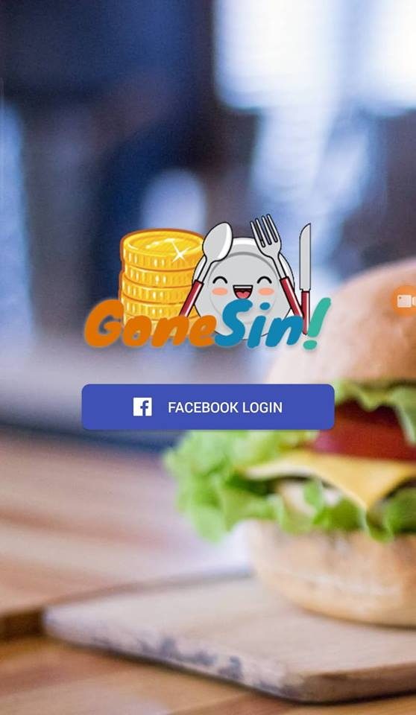

# Log in Page

In Log in Page, you need to enter your Facebook username and password and click Continues button to get the home page of Gone Sin Mal.

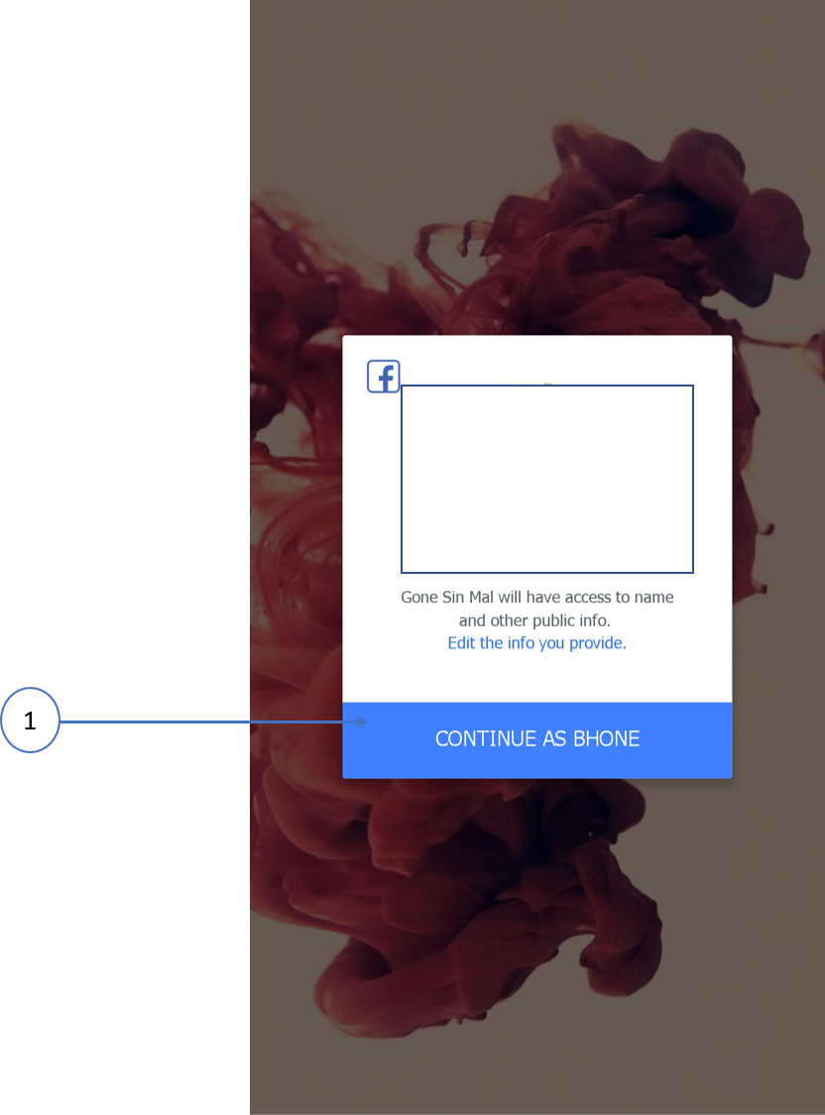

1. You can reach Admin home page of Gone Sin Mal by clicking Continues as Button.

# Navigation Bar

This is the navigation bar of the admin-side and you can navigate to other page or screen by clicking buttons.

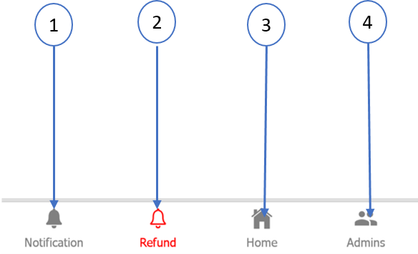

1. You can view notification message by clicking Notification button
2. You can reach the refund page by clicking the Refund button and Admin can refund the coins that restaurant owner request
3. You can view the coin status by clicking Home Button
4. You can find customers to pay admin by clicking Admin Button

# Home Page

This is the Admin Home page of the Gone Sin Mal app and you can view the coins status.

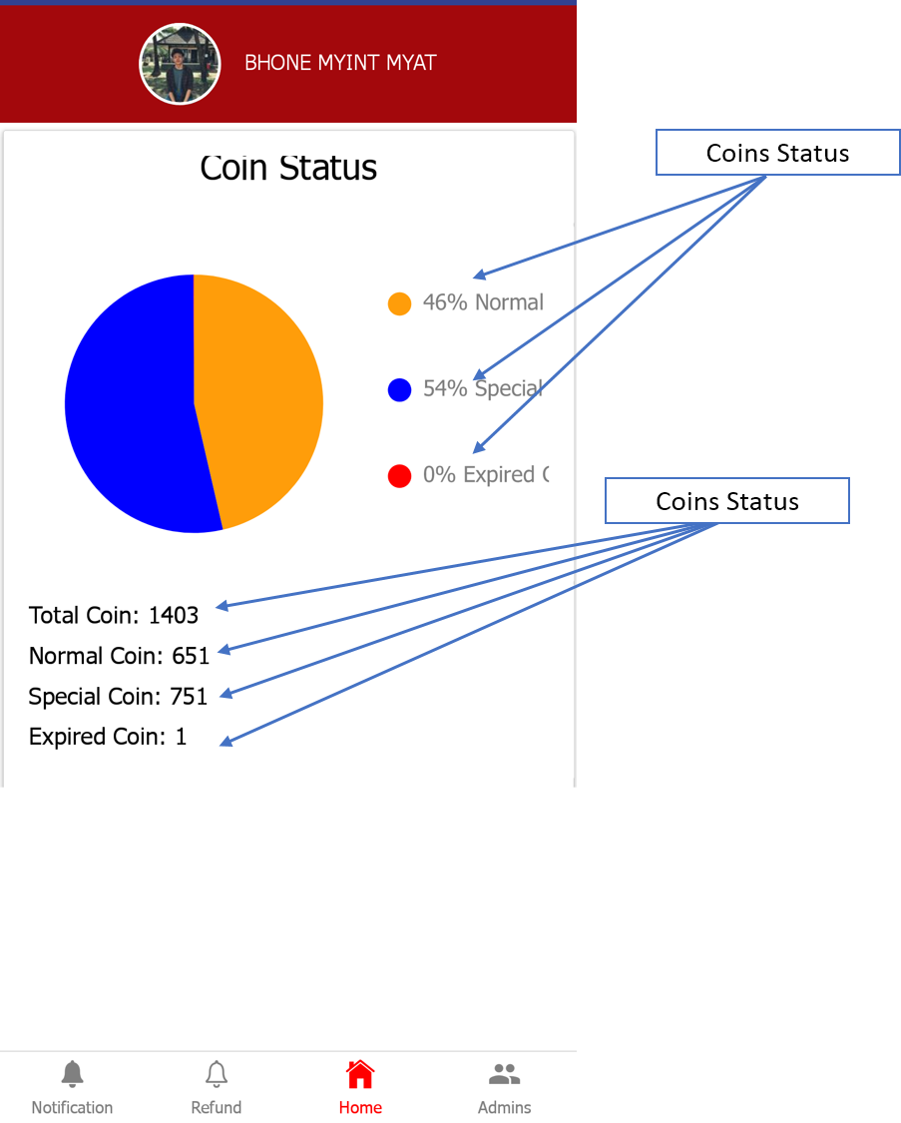

# Refund Page

In refund page, you can view the refund request from the restaurant owner.

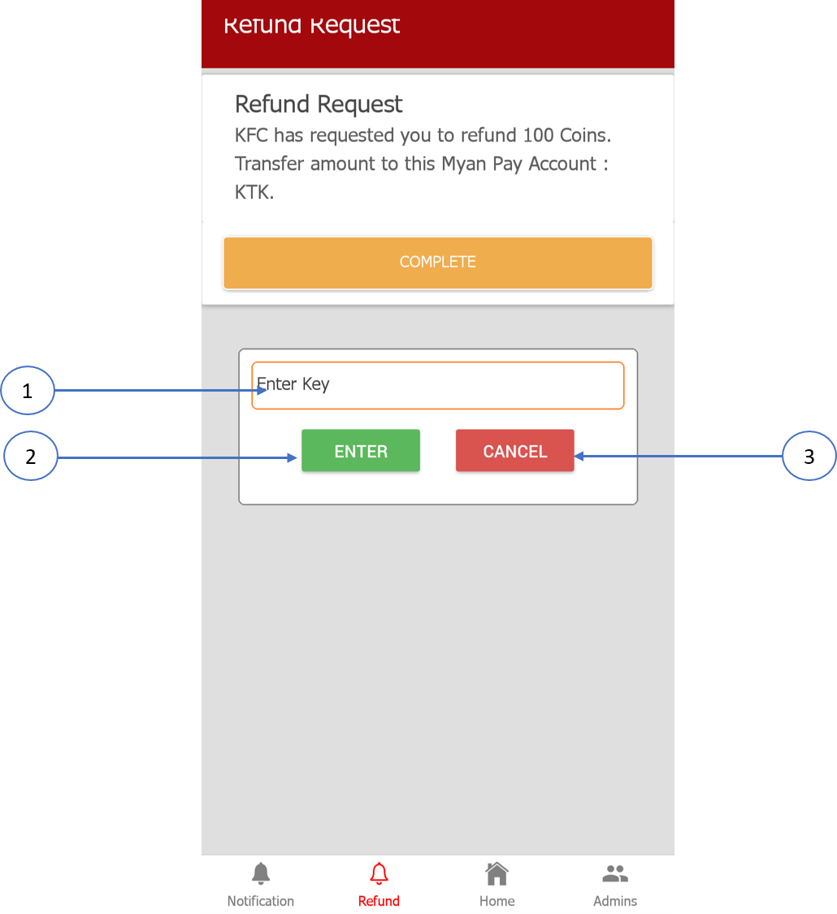

1. You need to enter admin key to access this function
2. If your key is correct, clicking the enter button can get access to refund
3. If you don’t have admin key, clicking cancel button and you will not have permission to refund

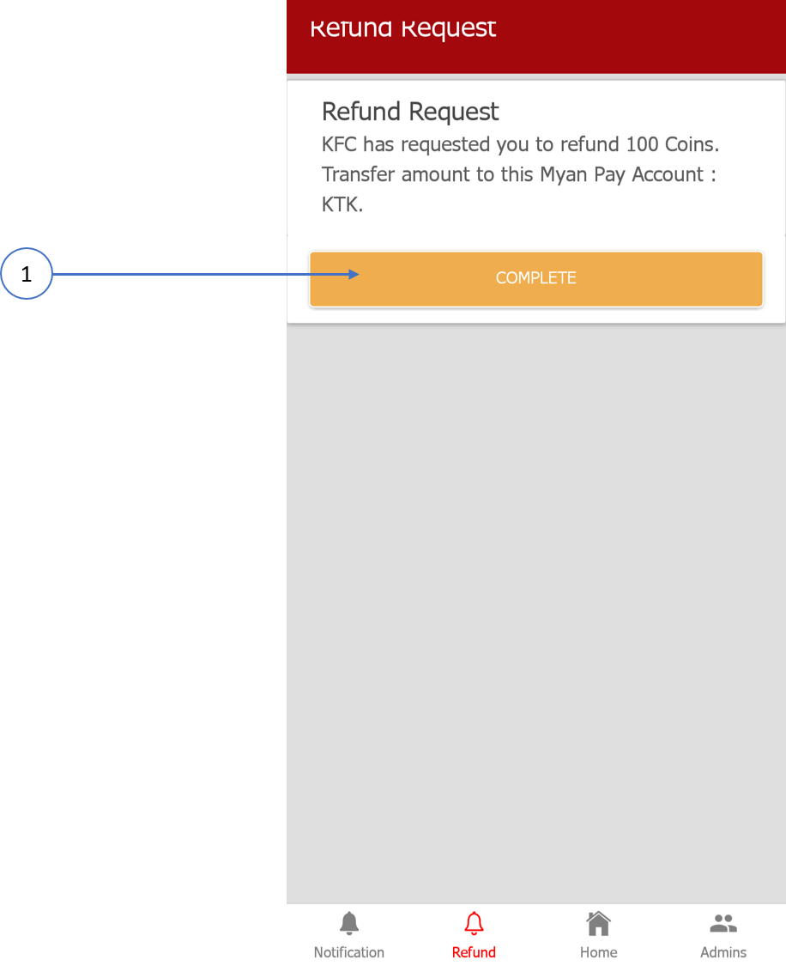

1. You can refund the coins and transfer money to restaurant owner by clicking Complete button

# Notification Page

This is the admin notification page of Gone Sin Mal and you can view the notification message like coins status.

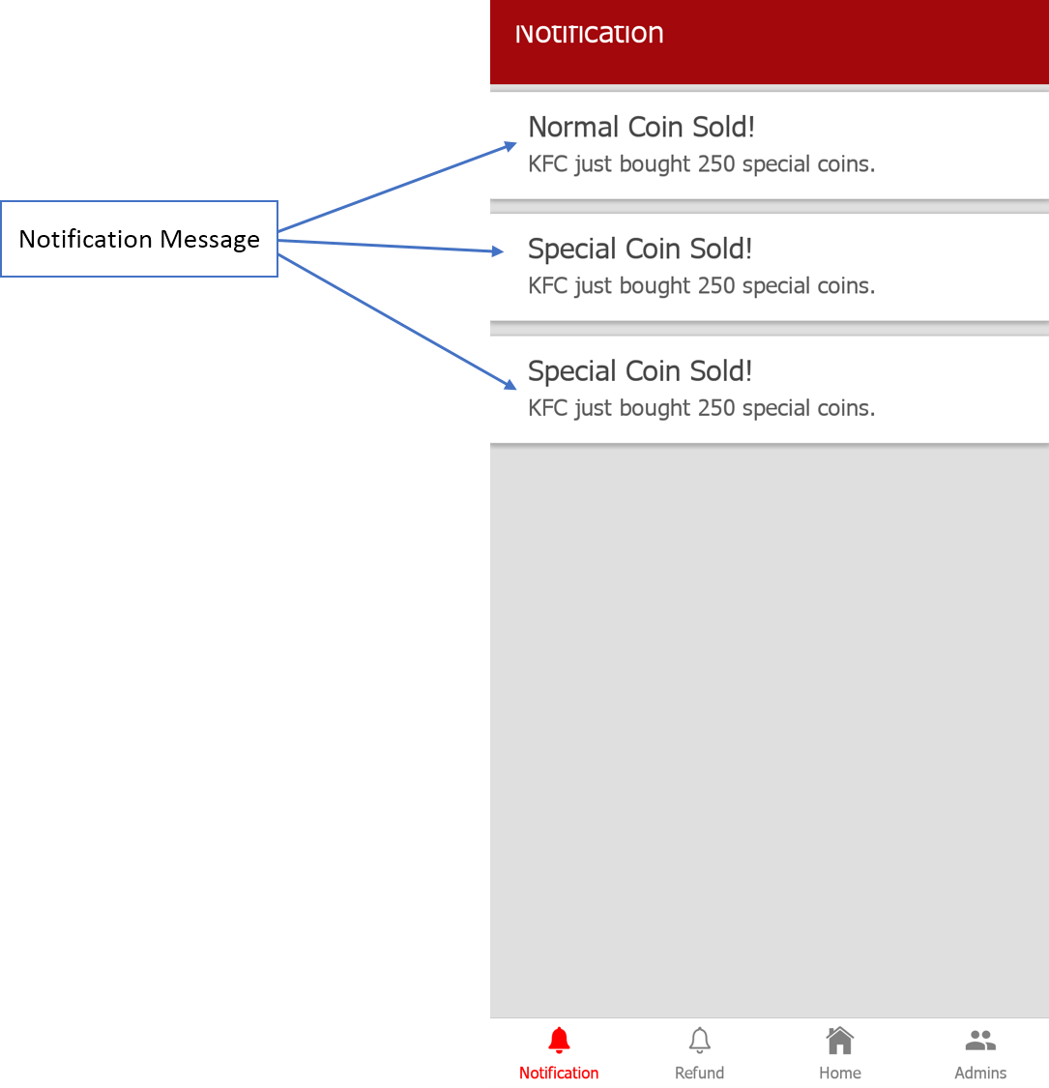

# Admin Page

In admin page, you can find the customer to pay admin of the Gone Sin Mal app by searching with username.

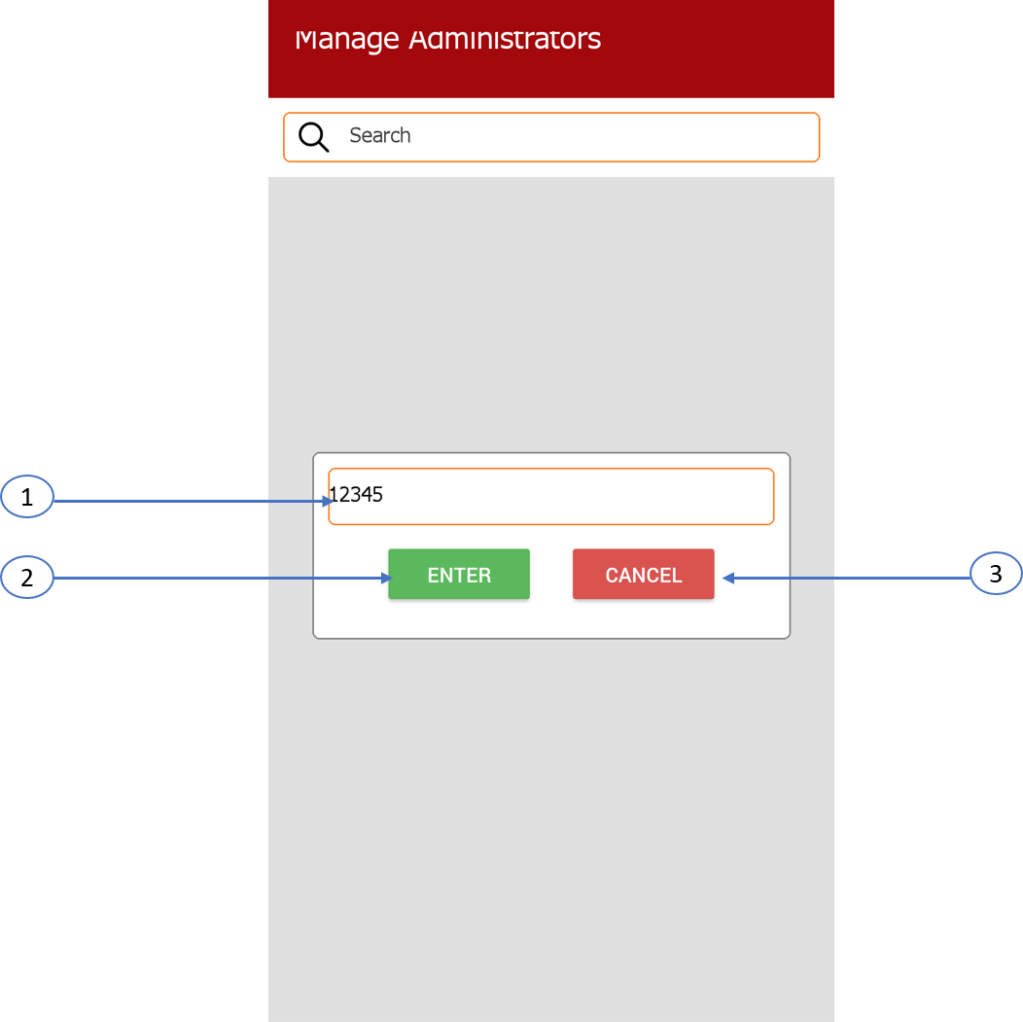

1. You need to enter admin key to get permission of manage admin functions
2. If your key is correct, you can click enter button to get access of these functions
3. If you don’t have admin key, clicking cancel button and you will not have permission to manage admin

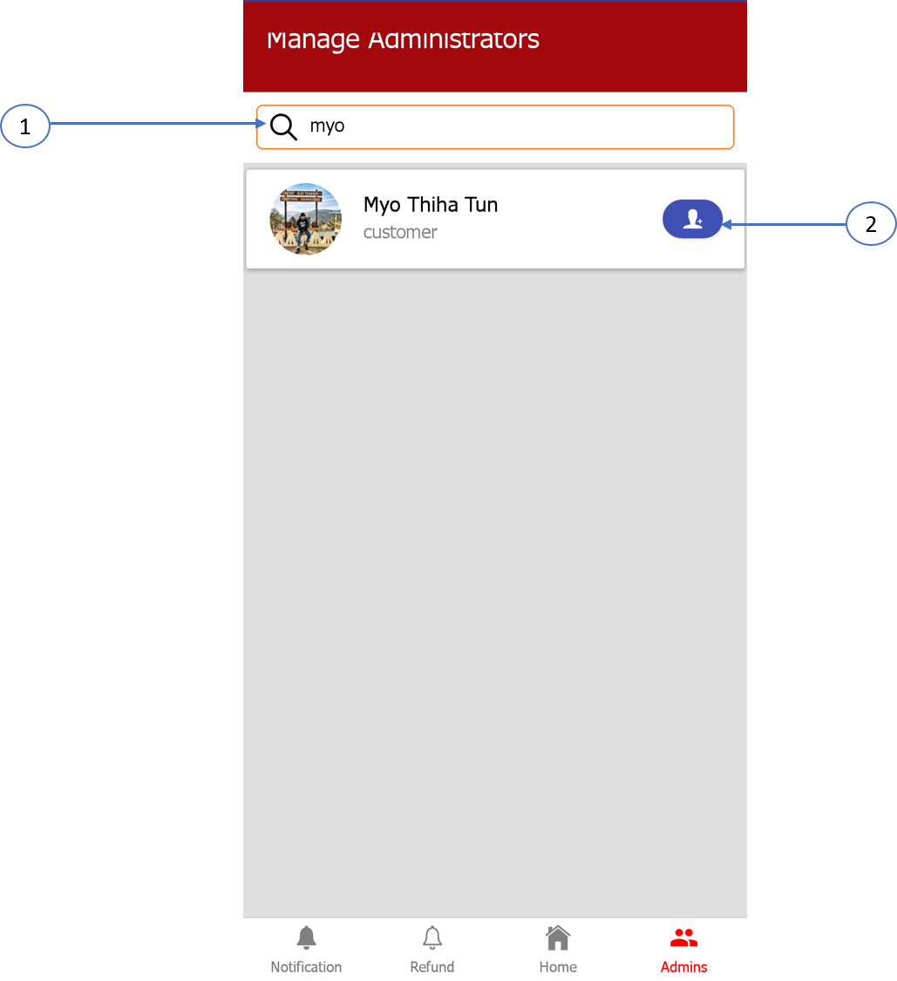

1. You can search the customer with username
2. You can pay admin by clicking the add button